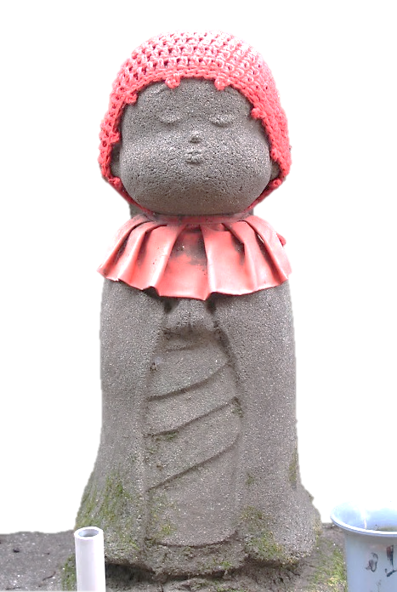
SAVE THE DATE!
Saturday, October 19, 2013
Women in Buddhism Conference
9:30 a.m. to 3:30 p.m.
Seattle Betsuin Buddhist Temple
1427 S Main St, Seattle WA 98199, (206) 329-0800

The Heart and Mind That Benefits Others

Rita no Kokoro
利他の心.

Speakers
Reverend Patti Usuki
San Fernando Buddhist Temple
Reverend Mariko Nishiyama
Pearl City Hongwanji Buddhist Temple
Associate Professor Naomi Kasumi
Department of Fine Arts, Seattle University

Details and Registration:
www.SeattleBetsuin.com

